Decision Tree
- Decision Tree is a Supervised learning technique that can be used for both classification and Regression problems, but mostly it is preferred for solving Classification problems. It is a tree-structured classifier, where internal nodes represent the features of a dataset, branches represent the decision rules and each leaf node represents the outcome.
- In a Decision tree, there are two nodes, which are the Decision Node and Leaf Node. Decision nodes are used to make any decision and have multiple branches, whereas Leaf nodes are the output of those decisions and do not contain any further branches.
- The decisions or the test are performed on the basis of features of the given dataset.
- It is a graphical representation for getting all the possible solutions to a problem/decision based on given conditions.
- It is called a decision tree because, similar to a tree, it starts with the root node, which expands on further branches and constructs a tree-like structure.
- In order to build a tree, we use the CART algorithm, which stands for Classification and Regression Tree algorithm.
- A decision tree simply asks a question, and based on the answer (Yes/No), it further split the tree into subtrees.
- Below diagram explains the general structure of a decision tree:
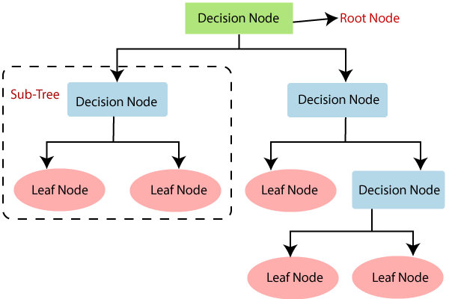

Decision Tree Terminologies
There are specialized terms associated with decision trees that denote various components and facets of the tree structure and decision-making procedure. :
- Root Node: A decision tree’s root node, which represents the original choice or feature from which the tree branches, is the highest node.
- Internal Nodes (Decision Nodes): Nodes in the tree whose choices are determined by the values of particular attributes. There are branches on these nodes that go to other nodes.
- Leaf Nodes (Terminal Nodes): The branches’ termini, when choices or forecasts are decided upon. There are no more branches on leaf nodes.
- Branches (Edges): Links between nodes that show how decisions are made in response to particular circumstances.
- Splitting: The process of dividing a node into two or more sub-nodes based on a decision criterion. It involves selecting a feature and a threshold to create subsets of data.
- Parent Node: A node that is split into child nodes. The original node from which a split originates.
- Child Node: Nodes created as a result of a split from a parent node.
- Decision Criterion: The rule or condition used to determine how the data should be split at a decision node. It involves comparing feature values against a threshold.
- Pruning: The process of removing branches or nodes from a decision tree to improve its generalization and prevent overfitting.

How decision tree algorithms work?

Decision Tree algorithm works in simpler steps

Starting at the Root: The algorithm begins at the top, called the “root node,” representing the entire dataset.
- Asking the Best Questions: It looks for the most important feature or question that splits the data into the most distinct groups. This is like asking a question at a fork in the tree.
- Branching Out: Based on the answer to that question, it divides the data into smaller subsets, creating new branches. Each branch represents a possible route through the tree.
- Repeating the Process: The algorithm continues asking questions and splitting the data at each branch until it reaches the final “leaf nodes,” representing the predicted outcomes or classifications.

Attribute Selection Measures
While implementing a Decision tree, the main issue arises that how to select the best attribute for the root node and for sub-nodes. So, to solve such problems there is a technique which is called as Attribute selection measure or ASM. By this measurement, we can easily select the best attribute for the nodes of the tree. There are two popular techniques for ASM, which are:
- Information Gain
- Gini Index

1. Information Gain:
- Information gain is the measurement of changes in entropy after the segmentation of a dataset based on an attribute.
- It calculates how much information a feature provides us about a class.
- According to the value of information gain, we split the node and build the decision tree.
- A decision tree algorithm always tries to maximize the value of information gain, and a node/attribute having the highest information gain is split first. It can be calculated using the below formula:
- Information Gain= Entropy(S)- [(Weighted Avg) *Entropy(each feature)
Entropy: Entropy is a metric to measure the impurity in a given attribute. It specifies randomness in data. Entropy can be calculated as:
Entropy(s)= -P(yes)log2 P(yes)- P(no) log2 P(no)
Where,
- S= Total number of samples
- P(yes)= probability of yes
- P(no)= probability of no

2. Gini Index:
- Gini index is a measure of impurity or purity used while creating a decision tree in the CART(Classification and Regression Tree) algorithm.
- An attribute with the low Gini index should be preferred as compared to the high Gini index.
- It only creates binary splits, and the CART algorithm uses the Gini index to create binary splits.
- Gini index can be calculated using the below formula:
Gini Index= 1- ∑_{j}P_{j}²

Example of a Decision Tree Algorithm
Forecasting Activities Using Weather Information
- Root node: Whole dataset
- Attribute : “Outlook” (sunny, cloudy, rainy).
- Subsets: Overcast, Rainy, and Sunny.
- Recursive Splitting: Divide the sunny subset even more according to humidity, for example.
- Leaf Nodes: Activities include “swimming,” “hiking,” and “staying inside.”

Beginning with the entire dataset as the root node of the decision tree:
- Determine the best attribute to split the dataset based on information gain, which is calculated by the formula: Information gain = Entropy(parent) – [Weighted average] * Entropy(children), where entropy is a measure of impurity or disorder of a set of examples, and the weighted average is based on the number of examples in each child node.
- Create a new internal node that corresponds to the best attribute and connects it to the root node. For example, if the best attribute is “outlook” (which can have values “sunny”, “overcast”, or “rainy”), we create a new node labeled “outlook” and connect it to the root node.
- Partition the dataset into subsets based on the values of the best attribute. For example, we create three subsets: one for instances where the outlook is “sunny”, one for instances where the outlook is “overcast”, and one for instances where the outlook is “rainy”.
- Recursively repeat steps 1-4 for each subset until all instances in a given subset belong to the same class or no further splitting is possible. For example, if the subset of instances where the outlook is “overcast” contains only instances where the activity is “hiking”, we assign a leaf node labeled “hiking” to this subset. If the subset of instances where the outlook is “sunny” is further split based on the humidity attribute, we repeat steps 2-4 for this subset.
- Assign a leaf node to each subset that contains instances that belong to the same class. For example, if the subset of instances where the outlook is “rainy” contains only instances where the activity is “stay inside”, we assign a leaf node labeled “stay inside” to this subset.
- Make predictions based on the decision tree by traversing it from the root node to a leaf node that corresponds to the instance being classified. For example, if the outlook is “sunny” and the humidity is “high”, we traverse the decision tree by following the “sunny” branch and then the “high humidity” branch, and we end up at a leaf node labeled “swimming”, which is our predicted activity.

When to Stop Splitting?
You must be asking this question to yourself that when do we stop growing our Decision tree? Usually, real-world datasets have a large number of features, which will result in a large number of splits, which in turn gives a huge tree. Such trees take time to build and can lead to overfitting. That means the tree will give very good accuracy on the training dataset but will give bad accuracy in test data.There are many ways to tackle this problem through hyperparameter tuning. We can set the maximum depth of our decision tree using themax_depth parameter. The more the value of max_depth, the more complex your tree will be. The training error will off-course decrease if we increase the max_depth value but when our test data comes into the picture, we will get a very bad accuracy. Hence you need a value that will not overfit as well as underfit our data and for this, you can use GridSearchCV.
Another way is to set the minimum number of samples for each spilt. It is denoted by min_samples_split. Here we specify the minimum number of samples required to do a spilt. For example, we can use a minimum of 10 samples to reach a decision. That means if a node has less than 10 samples then using this parameter, we can stop the further splitting of this node and make it a leaf node.
There are more hyperparameters such as :
min_samples_leaf – represents the minimum number of samples required to be in the leaf node. The more you increase the number, the more is the possibility of overfitting.
max_features – it helps us decide what number of features to consider when looking for the best split.

Pruning
Pruning is another method that can help us avoid overfitting. It helps in improving the performance of the Decision tree by cutting the nodes or sub-nodes which are not significant. Additionally, it removes the branches which have very low importance.
There are mainly 2 ways for pruning:
Pre-pruning – we can stop growing the tree earlier, which means we can prune/remove/cut a node if it has low importance while growing the tree.

Post-pruning – once our tree is built to its depth, we can start pruning the nodes based on their significance.

Advantages of Decision Tree
- Easy to understand and interpret, making them accessible to non-experts.
- Handle both numerical and categorical data without requiring extensive preprocessing.
- Provides insights into feature importance for decision-making.
- Handle missing values and outliers without significant impact.
- Applicable to both classification and regression tasks.

Disadvantages of Decision Tree
- Disadvantages include the potential for overfitting
- Sensitivity to small changes in data, limited generalization if training data is not representative
- Potential bias in the presence of imbalanced data.

Conclusion
Decision trees, a key tool in machine learning, model and predict outcomes based on input data through a tree-like structure. They offer interpretability, versatility, and simple visualization, making them valuable for both categorization and regression tasks. While decision trees have advantages like ease of understanding, they may face challenges such as overfitting. Understanding their terminologies and formation process is essential for effective application in diverse scenarios.

Frequently Asked Questions (FAQs)

What are the major issues in decision tree learning?
Major issues in decision tree learning include overfitting, sensitivity to small data changes, and limited generalization. Ensuring proper pruning, tuning, and handling imbalanced data can help mitigate these challenges for more robust decision tree models.

How does decision tree help in decision making?
Decision trees aid decision-making by representing complex choices in a hierarchical structure. Each node tests specific attributes, guiding decisions based on data values. Leaf nodes provide final outcomes, offering a clear and interpretable path for decision analysis in machine learning.

What is the maximum depth of a decision tree?
The maximum depth of a decision tree is a hyperparameter that determines the maximum number of levels or nodes from the root to any leaf. It controls the complexity of the tree and helps prevent overfitting.

What is the concept of decision tree?
A decision tree is a supervised learning algorithm that models decisions based on input features. It forms a tree-like structure where each internal node represents a decision based on an attribute, leading to leaf nodes representing outcomes.

What is entropy in decision tree?
In decision trees, entropy is a measure of impurity or disorder within a dataset. It quantifies the uncertainty associated with classifying instances, guiding the algorithm to make informative splits for effective decision-making.

What are the Hyperparameters of decision tree?
- Max Depth: Maximum depth of the tree.
- Min Samples Split: Minimum samples required to split an internal node.
- Min Samples Leaf: Minimum samples required in a leaf node.
- Criterion: The function used to measure the quality of a split

What is the difference between Post-pruning and Pre-pruning?
Pruning involves cutting back the tree. After a tree has been built, it might have to overfit the data. There are many ways to prune a tree, some of which are:
- Minimum error: The tree is pruned back to the point where the cross-validation error is minimum.
- Smallest tree: The tree is pruned back slightly further than the minimum error.
Pre-pruning is also known as early stopping. In this method, the overfitting of the data may also be prevented by stopping the tree-building process early (before it produces leaf nodes with very small samples). Pre-pruning can underfit the data by stopping too early. A method to pre-prune a tree is described below:
- At each stage of splitting the tree, the cross-validation error can be checked. If the error does not decrease significantly enough then the process can be stopped.
- Pruning and pre-pruning can both be used together, separately, or not at all. Post-pruning is more mathematically rigorous when compared to pre-pruning.

Why do you need to Prune the decision tree?
After a tree has been built (and in the absence of early stopping discussed below) it may be overfitted. Pruning reduces the size of decision trees by removing parts of the tree that do not provide the power to classify instances.
- Pruning the tree after it learns can increase its performance.
- Pruning is a technique that reduces the size of the decision trees by removing sections of the tree that are non-critical and redundant to classify instances.
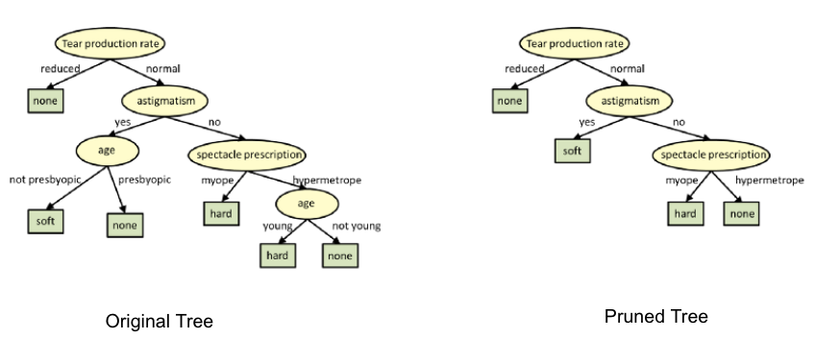
- If the tree is too large then there is a risk of overfitting, but if the tree is too small then it will not be able to generalize the problem. Pruning helps to keep the tree in a reduced size without affecting its performance in a bad way.
- We can use cross-validation to see how the error in the tree changes with the size of the tree. Beyond some size, the cross-validation error gradually increases, which can be a sign of overfitting.

Decision Trees Interview Questions & Answers

Q1. What is the Decision Tree Algorithm?
A Decision Tree is a supervised machine-learning algorithm that can be used for both Regression and Classification problem statements. It divides the complete dataset into smaller subsets while, at the same time, an associated Decision Tree is incrementally developed.
A machine learning model like a decision tree can be easily trained on a dataset by finding the best splits to make at each node. The Decision Trees’ final output is a Tree with Decision nodes and leaf nodes. A Decision Tree can operate on both categorical and numerical data.

Unlike Deep Learning, Decision Trees are easy to interpret and understand, making them a popular choice for decision-making applications in various industries. You can create a decision tree model with a programming language like Python using the scikit-learn library or with R. code.
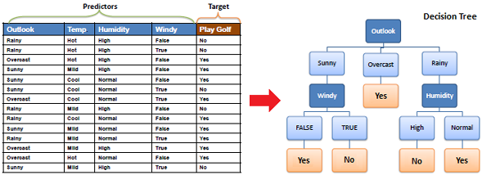

Q2. List down some popular algorithms used for deriving Decision Trees and their attribute selection measures.
Some of the popular algorithms used for constructing decision trees are:
- ID3 (Iterative Dichotomiser): Uses Information Gain as an attribute selection measure.
- C4.5 (Successor of ID3): UsesGain Ratio as an attribute selection measure.
- CART (Classification algorithm and Regression Trees) – Uses Gini Index as an attribute selection measure.

Q3. Explain the CART Algorithm for Decision Trees.
The CART stands for Classification and Regression Trees, is a greedy algorithm that greedily searches for an optimum split at the top level, then repeats the same process at each of the subsequent levels.
Moreover, it verifies whether the split will lead to the lowest impurity, and the solution provided by the greedy algorithm is not guaranteed to be optimal. It often produces a reasonably good solution since finding the optimal Tree is an NP-Complete problem requiring exponential time complexity.
As a result, it makes the problem intractable even for small training sets. This is why we must choose a “reasonably good” solution instead of an optimal one.

Q4. List down the attribute selection measures used by the ID3 algorithm to construct a Decision Tree.
The most widely used algorithm for building a Decision Tree is called ID3. ID3 uses Entropy and Information Gain as attribute selection measures to construct a Decision Tree.
1. Entropy: A Decision Tree is built top-down from a root node and involves the partitioning of data into homogeneous subsets. To check the homogeneity of a sample, ID3 uses entropy. Therefore, entropy is zero when the sample is completely homogeneous, and entropy of one when the sample is equally divided between different classes.
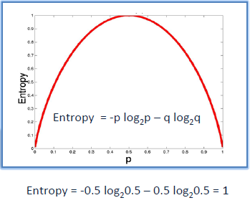
2. Information Gain: Information Gain is based on the decrease in entropy after splitting a dataset based on an attribute. The meaning of constructing a Decision Tree is all about finding the attributes having the highest information gain.
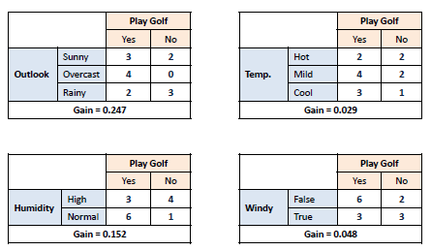
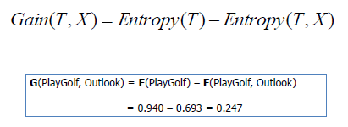

Q5. Briefly explain the properties of Gini Impurity.
Let X (discrete random variable) takes values y₊ and y₋ (two classes). Now, let’s consider the different cases:
Case- 1: When 100% of observations belong to y₊ . Then, the Gini impurity of the system would be:
Case- 2: When 50% of observations belong to y₊ . Then, the Gini impurity of the system would be:
Case- 3: When 0% of observations belong to y₊ . Then, the Gini impurity of the system would be:
After observing all these cases, the graph of Gini impurity w.r.t to y₊ would come out to be:

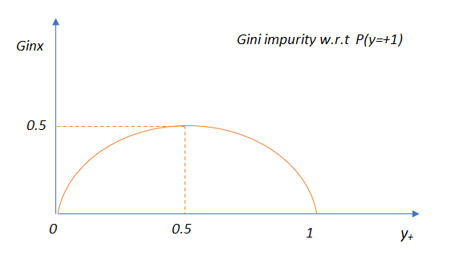

Q6. Explain the difference between the CART and ID3 Algorithms.
The CART algorithm produces only binary Trees: non-leaf nodes always have two children (i.e., questions only have yes/no answers).
On the contrary, other Tree algorithms, such as ID3, can produce Decision Trees with nodes having more than two children.

Q7. Which should be preferred among Gini impurity and Entropy?
In reality, most of the time, it does not make a big difference: they lead to almost similar Trees. Gini impurity is a good default while implementing in sklearn since it is slightly faster to compute. However, when they work differently, then Gini impurity tends to isolate the most frequent class in its own branch of the Tree, while entropy tends to produce slightly more balanced Trees.

Q8. List down the different types of nodes in Decision Trees.
The Decision Tree consists of the following different types of nodes:
- Root node: It is the top-most node of the Tree from where the Tree starts.
- Decision nodes: One or more decision nodes that result in the splitting of data into multiple data segments. Our main goal is to have the children nodes with maximum homogeneity or purity.
- Leaf nodes: These nodes represent the data section having the highest homogeneity.

Q9. What do you understand about Information Gain? Also, explain the mathematical formulation associated with it.
Information gain is the difference between the entropy of a data segment before and after the split, i.e., reduction in impurity due to the selection of an attribute.
Some points to keep in mind about information gain:
- The high difference represents high information gain.
- The higher the difference implies the lower entropy of all data segments resulting from the split.
- Thus, the higher the difference, the higher the information gain, and the better the feature used for the split.
Mathematically, the information gain can be computed by the equation as follows:
Information Gain = E(S1) – E(S2)
– E(S1) denotes the entropy of data belonging to the node before the split.
– E(S2) denotes the weighted summation of the entropy of children nodes by considering the weights as the proportion of data instances falling in specific children nodes.

Q10. Do we require Feature Scaling for Decision Trees? Explain.
Decision Trees are mainly intuitive, easy to interpret, and require fewer data preparation. In fact, they don’t require feature scaling or centering(standardization) at all. Such models are often called white-box models. Decision Trees provide simple classification rules based on if and else statements that can even be applied manually if necessary.
For Example, Flower classification for the Iris dataset.

Q11. What are the disadvantages of Information Gain?
Information gain is defined as the reduction in entropy due to the selection of a particular attribute. Information gain biases the Decision Tree against considering attributes with a large number of distinct values, which might lead to overfitting.
The information Gain Ratio is used to solve this problem.

Q12. List down the problem domains in which Decision Trees are most suitable.
Decision Trees are suitable for the following cases:
- Decision Trees are most suitable for tabular data.
- The outputs are discrete.
- Explanations for Decisions are required.
- The training data may contain errors and noisy data(outliers).
- The training data may contain missing feature values.

Q13. Explain the time and space complexity of training and testing in the case of a Decision Tree.
Time and Space complexity for Training:
In the training stage for features (dimensions) in the dataset, we sort the data, which takes O(n log n) time, following which we traverse the data points to find the right threshold, which takes O(n) time. Subsequently, for d dimensions, the total time complexity would be:
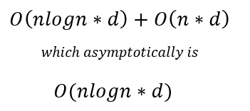
Usually, while training a decision tree, we identify the nodes, which are typically stored in the form of if-else statements, due to which training space complexity is O(nodes).
Time and Space Complexity for Testing:
Moreover, the testing time complexity is O(depth) as we have to traverse from the root to a leaf node of the decision tree, i.e., testing space complexity is O(nodes).

Q14. If it takes one hour to train a Decision Tree on a training set containing 1 million instances, roughly how much time will it take to train another Decision Tree on a training set containing 10 million instances?
As we know that the computational complexity of training a Decision Tree is given by O(n × m log(m)). So, when we multiply the size of the training set by 10, then the training time will be multiplied by some factor, say K.
Now, we have to determine the value of K. To finds K, divide the complexity of both:
K = (n × 10m × log(10m)) / (n × m × log(m)) = 10 × log(10m) / log(m)
For 10 million instances, i.e., m = 106, then we get the value of K ≈ 11.7.
Therefore, we can expect the training time to be roughly 11.7 hours.

Q15. How does a Decision Tree handle missing attribute values?
Decision Trees handle missing values in the following ways:
- Fill the missing attribute value with the most common value of that attribute.
- Fill in the missing value by assigning a probability to each of the possible values of the attribute based on other samples.

Q16. How does a Decision Tree handle continuous(numerical) features?
Decision Trees handle continuous features by converting these continuous features to a threshold-based boolean feature. To decide the threshold value, we use the concept of Information Gain, choosing the threshold that maximizes the information gain.

Q17. What is the Inductive Bias of Decision Trees?
The ID3 algorithm preferred Shorter Trees over longer Trees. In Decision Trees, attributes with high information gain are placed close to the root and are preferred over those without. In the case of decision trees, the depth of the trees is the inductive bias. If the depth of the tree is too low, then there is too much generalization in the model.

Q18. Explain Feature Selection using the Information Gain/Entropy Technique.
The goal of the feature selection while building a Decision Tree is to select features or attributes (Decision nodes) which lead to a split in children nodes whose combined entropy adds up to lower entropy than the entropy value of the data segment before the split. This implies higher information gain.

Q19. Compare the different attribute selection measures.
The three measures, in general, returns good results, but:
- Information Gain: It is biased towards multivalued attributes
- Gain ratio: It prefers unbalanced splits in which one data segment is much smaller than the other segment.
- Gini Index: It is biased to multivalued attributes, has difficulty when the number of classes is large, and tends to favor tests that result in equal-sized partitions and purity in both partitions.

Q20. Why do we require Pruning in Decision Trees? Explain.
After we create a Decision Tree, we observe that most of the time, the leaf nodes have very high homogeneity, i.e., properly classified data. However, this also leads to overfitting. Moreover, if enough partitioning is not carried out, it would lead to underfitting.
Hence, the major challenge is finding the optimal trees that result in the appropriate classification having acceptable accuracy. So to cater to those problems, we first make the decision tree and then use the error rates to prune the trees appropriately. Boosting can also be used to increase the accuracy of the model by combining the predictions of multiple weak learners into a stronger learner.

Q21. Are Decision Trees affected by the outliers? Explain.
Decision Trees are not sensitive to noisy data or outliers since extreme values or outliers never cause much reduction in the Residual Sum of Squares(RSS) because they are never involved in the split. Decision Trees are generally robust to outliers. Due to their tendency to overfit, they are prone to sampling errors. If sampled training data is somewhat different than evaluation or scoring data, then Decision Trees tend not to produce great results.

Q22. What do you understand by Pruning in a Decision Tree?
The process of removing sub-nodes of a Decision node is called pruning, which is the opposite process of splitting. The two most widely used techniques for pruning are Post and Pre-Pruning.
Post Pruning:
- This type of pruning is used after the construction of the Decision Tree.
- This technique is used when the Decision Tree has a tremendous depth and will show the overfitting of the model.
- It is also known as backward pruning.
- This technique is used when we have an infinitely grown Decision Tree.
Pre Pruning:
- This technique is used before the construction of the Decision Tree.
- Pre-Pruning can be done using Hyperparameter tuning.
- Overcome the overfitting issue.

Q23. List down the advantages of the Decision Trees.
1. Clear Visualization: This algorithm is simple to understand, interpret and visualize as the idea is mostly used in our daily lives. The output of a Decision Tree can be easily interpreted by humans.
2. Simple and easy to understand: Decision Tree works in the same manner as simple if-else statements, which are very easy to understand.
3. This can be used for both classification and regression problems.
4. Decision Trees can handle both continuous and categorical variables.
5. No feature scaling required: There is no requirement for feature scaling techniques such as standardization and normalization in the case of a Decision Tree, as it uses a rule-based approach instead of calculating distances.
6. Handles nonlinear parameters efficiently: Unlike curve-based algorithms, the performance of decision trees can’t be affected by non-linear parameters. So, if there is high non-linearity present between the independent variables, Decision Trees may outperform as compared to other curve-based algorithms.
7. Decision Tree can automatically handle missing values.
8. Decision Tree handles the outliers automatically; hence they are usually robust to outliers.
9. Less Training Period: The training period of decision trees is less than that of ensemble techniques like Random Forest because it generates only one Tree, unlike the forest of trees in the Random Forest.

Q24. List out the disadvantages of the Decision Trees.
1. Overfitting: This is the major problem associated with Decision Trees. It generally leads to overfitting the data, ultimately leading to wrong predictions for testing data points. It keeps generating new nodes to fit the data, including even noisy data, making the Tree too complex to interpret. In this way, it loses its generalization capabilities. Therefore, it performs well on the training dataset but starts making a lot of mistakes on the test set.
2. High variance: As mentioned, a Decision Tree generally leads to the overfitting of data. Due to the overfitting, there is more likely a chance of high variance in the output, leading to many errors in the final predictions and high inaccuracy in the results. So, achieving zero bias (overfitting) leads to high variance due to the bias-variance tradeoff. You can use an ensemble learning method like Bagging to reduce the prediction variance and make the model more robust to noisy or outlier data points.
3. Unstable: Adding new data points can lead to the regeneration of the overall Tree. Therefore, all nodes need to be recalculated and reconstructed.
4. Not suitable for large datasets: If the data size is large, then one single Tree may grow complex and lead to overfitting. So, in this case, we should use Random Forest instead, an ensemble technique of a single Decision Tree.

Q25. What is the role of decision trees in artificial intelligence and machine learning?
Decision trees are simple to interpret and visualize. Also, they can handle both categorical and numerical data. Decision trees can handle non-linear relationships between variables and are robust to outliers. These factors make it a popular choice for various applications in artificial intelligence and machine learning, like natural language processing (NLP), computer vision, and predictive analytics.

Q26. How does the decision tree compare with linear regression and logistic regression?
Decision trees are useful in situations where the relationship between the features and the target variable is non-linear and complex. Still, they can easily overfit the data and produce overly complex models. In some cases, decision trees may provide higher accuracy and be more applicable to real-world problems, while in other cases, linear or logistic regression may perform better. The choice of algorithm will depend on the nature of the problem and the data being analyzed.

Q27. What are the trade-offs of using decision trees vs. neural networks for certain machine learning applications?
Decision trees are known for their simplicity, interpretability, and ease of use but may not be as accurate as neural networks for complex problems. Neural networks are known for their high accuracy; however, they are computationally intensive, making them more difficult to train and implement than decision trees.

Q28. What are some of the alternative algorithms to decision trees?
Some of the alternative algorithms to decision trees are Random Forest, Gradient Boosting, k-Nearest Neighbors (KNN, it labeled data), Logistic Regression, Support Vector Machines (SVMs), Naive Bayes, and Neural Networks.

Q29. What common mistakes do beginners make when working with decision trees, and how can you avoid them?
The mistakes beginners would usually make when working with decision trees include overfitting the model to the training data, not properly handling missing values, and not considering the possibility of class imbalance. One can avoid these by using techniques such as pruning the tree, imputing missing values, and performing stratified sampling to balance the class distribution.

Conclusion
Decision Trees are a supervised learning machine-learning technique that can be used for both regression and classification problems. You create a tree-based model that splits the data into different branches based on a few conditions. The final prediction is made by traversing the tree and making decisions based on the values of the input variables. Decision Trees can be trained using metrics such as Gini Impurity or Entropy, and their performance can be evaluated using metrics such as accuracy, precision, recall, F1 score, and ROC-AUC, confusion matrix(It shows the number of true positive, true negative, false positive, and false negative predictions made by the model).
Key Takeaways
- The Decision Tree algorithm works by splitting the data into smaller subsets based on the feature values until the data can be split no further into homogeneous groups.
- The final result is a tree-like structure, where each internal node represents a feature, and each leaf node represents the predicted output.
- Decision Trees are simple and allow you to understand the reasoning behind the predictions made by the model. Decision Trees can be prone to overfitting, particularly when dealing with noisy or complex data.

